Title of the Abstract

First Author¹, Second Author ², Corresponding Author^{1,}*

¹Department of Chemistry, University of xxxxxx, Postal address, City, Post code
²Institute of Chemistry, Chinese Academy of Sciences, Postal address, City, Post code

e-mail : xxx@nankai.edu.cn

Abstract text in English, Times New Roman, 150 words maximum, single space.
Figure size 140 x 40 maximum.

Graphic Abstract (Insert TOC Graphic here)
Fig. 1 Figure title

References
- A. Surname, B.-C. Surname, D.-E. Surname J .Org. Chem. 2019, 37, xxxx.
2.
3.

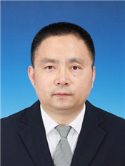
Chi Zhang, Ph.D.
1986-1990, B. S. in Chemistry, Lanzhou University, China
1993-1996, M. Sc. in Chemistry, Lanzhou University, China
1996-2001, Ph. D in Chemistry, The University of Hong Kong, China
2001-2003, Postdoctoral Fellow. Stanford University
2003- Professor in Chemistry, Nankai University
Research interests：Hypervalent iodine chemistry, C-H bond Functionalization, Green synthesis of organic fluorides.

